CREFC 10-D Forms
Procedure

Monthly CMBS Investor Reporting Workflow
From IRP Download Through Signed 10-D Delivery
Gantry | Asset Management
Version 1.0 | April 2026

Table of Contents
1. Overview
What this procedure covers and when to use it
2. Step 1 — Download the IRP from Production Portal
Detailed walkthrough with portal screenshots
3. Step 2 — Run the Python Reporting Tool
Launching the .bat file and confirming the run
4. Step 3 — Review the Run Log
Understanding the Excel log output
5. Step 4 — Spot-Check the CREFC Files
Validating Periodic, Property, Supplemental, and Financial files
6. Step 5 — Upload CREFC Files to Servicer
Submitting completed CREFC forms
7. Step 6 — Prepare the 10-D Forms
Updating the 10D Forms.xlsx template and converting to PDF
8. Step 7 — Email 10-D PDF to Michael for Signature
Sending the form for execution
9. Step 8 — Process and Distribute Signed 10-Ds
Split script, email script, and archiving signed forms
10. Quick Reference
Key paths, contacts, and timing at a glance

1. Overview
Each month, Gantry is required to submit updated CREFC 10-D forms to the master servicer (Trimont) for every active CMBS deal. The end-to-end process involves five phases:
1. Download the Investor Reporting Package (IRP) from the trustee’s Production Portal.
2. Run the Python Reporting Tool to generate updated CREFC files (Periodic, Property, Supplemental, Financial) for each deal.
3. Review and spot-check the tool’s output against IRP source data.
4. Upload the completed CREFC files to each servicer.
5. Prepare the 10-D forms, obtain Michael Heagerty’s signature, and email the signed 10-Ds to Trimont.
This document covers every step from start to finish. The CREFC files are generated by an automated Python tool; the 10-D forms are a separate Excel template that you update manually, convert to PDF, and route for signature.

Two Determination-Date Batches
Deals are split into two batches based on their determination date. Each batch has its own distribution date and must be processed and delivered separately:
Batch | Determination Date | Distribution Date
Batch 1 | 6th of the month | Four business days after the 6th
Batch 2 | 11th of the month | Four business days after the 11th
Note: If the 6th or 11th falls on a weekend or holiday, the determination date moves to the next business day, which also shifts the distribution date.

2. Step 1 — Download the IRP from Production Portal
The Investor Reporting Package (IRP) is a set of Excel files downloaded from the trustee’s Production Portal (GANDATA/Strategy). The tool needs two files: the PIRPXLPU file (loan-level payment data) and the PIRPXLLR file (reserve/LOC data). Follow these steps exactly as shown.

Log In to the Production Portal
1. Navigate to the GANDATA Production Portal
Open your browser and go to https://ganwebp.mfsasp.com/MWS_DASH/Main-en_US.html. You will see the Strategy login page.
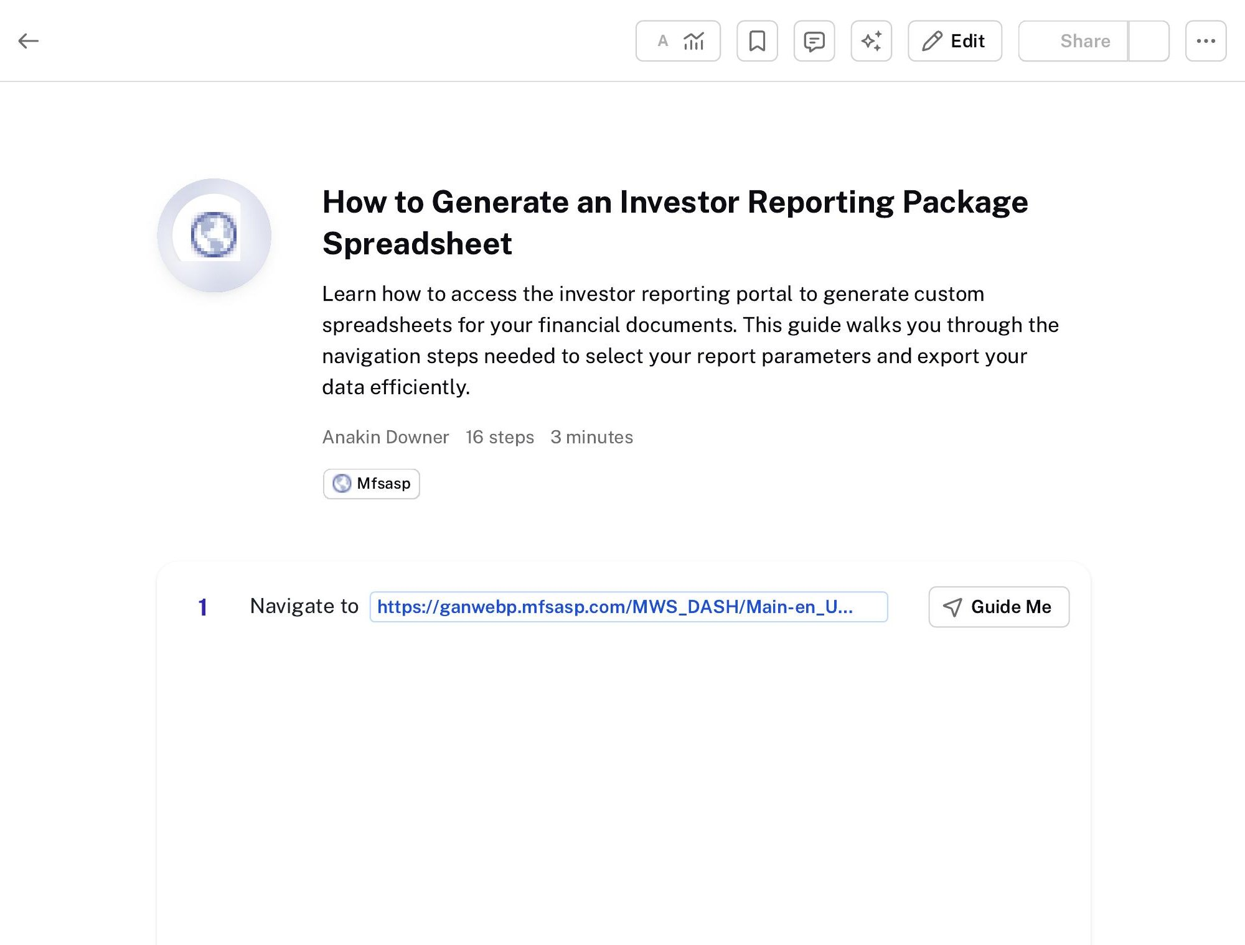
2. Enter your credentials
Click the Password field and enter your GANDATA password. Your User ID should be pre-filled. Make sure the Datalibrary dropdown is set to “GANDATA.”
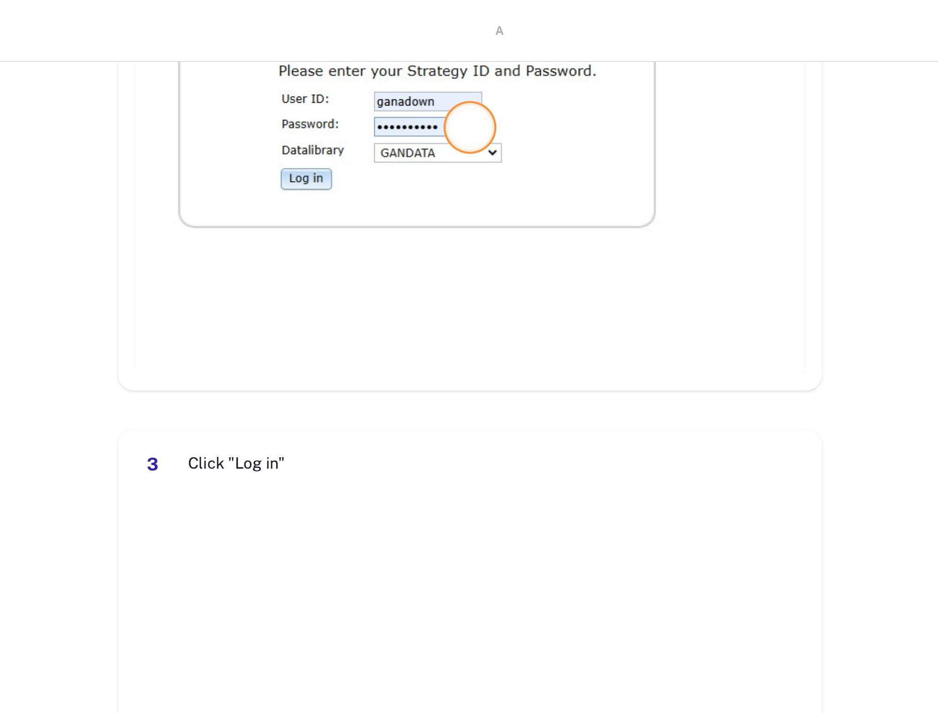
3. Click “Log in”
Click the Log in button to access the portal dashboard.

Open the Investor Reporting Package Widget
4. Click “Investor Reporting Package”
On the dashboard, locate and click the “Investor Reporting Package” widget (blue button on the left-side menu). This opens the IRP report generator.
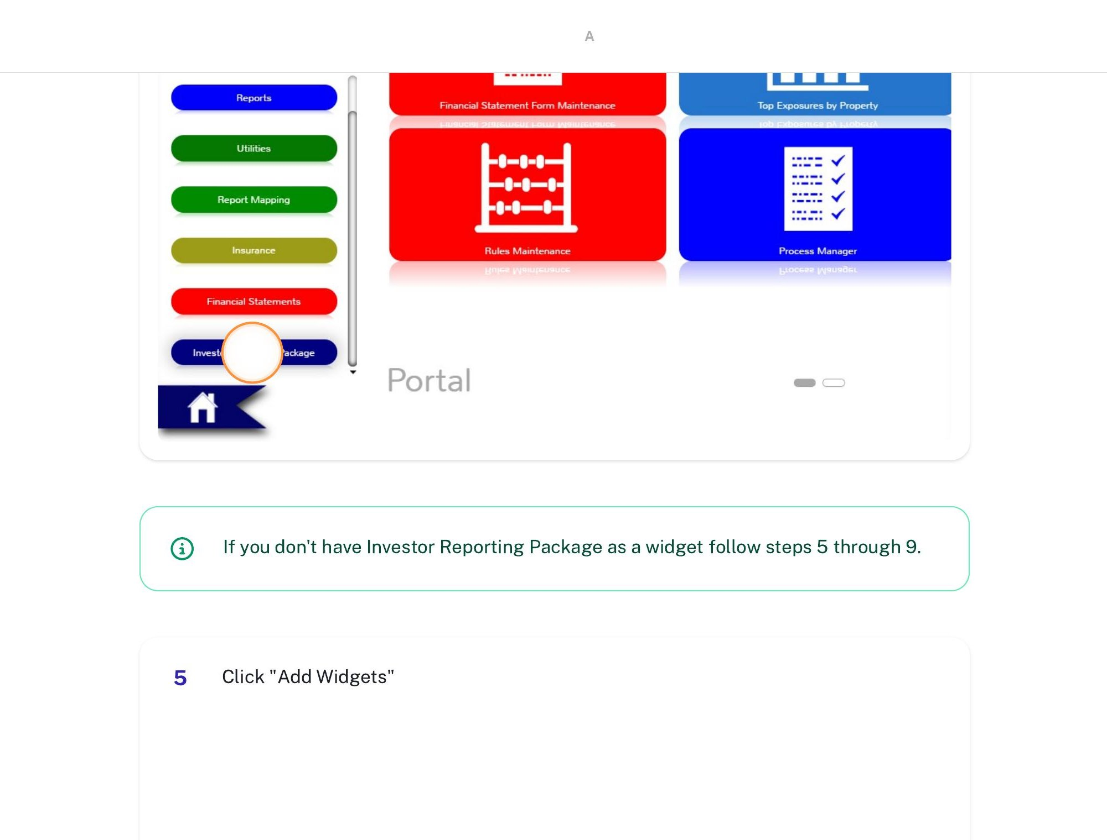
Tip: If you don’t have the Investor Reporting Package widget on your dashboard, follow steps 5–9 below to add it. Otherwise, skip to step 10.

Add the Widget (if needed)
5. Click “Add Widgets”
Click the “Add Widgets” button (near the “Lock Portal” checkbox at the bottom-right) to open the widget gallery.
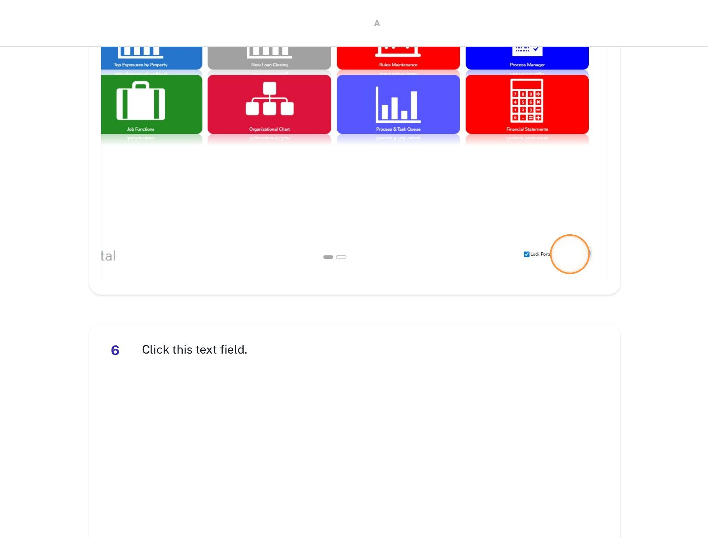
6. Search for “Investor Reporting Package”
Click the search text field in the widget dialog and type “Investor Reporting Package.”
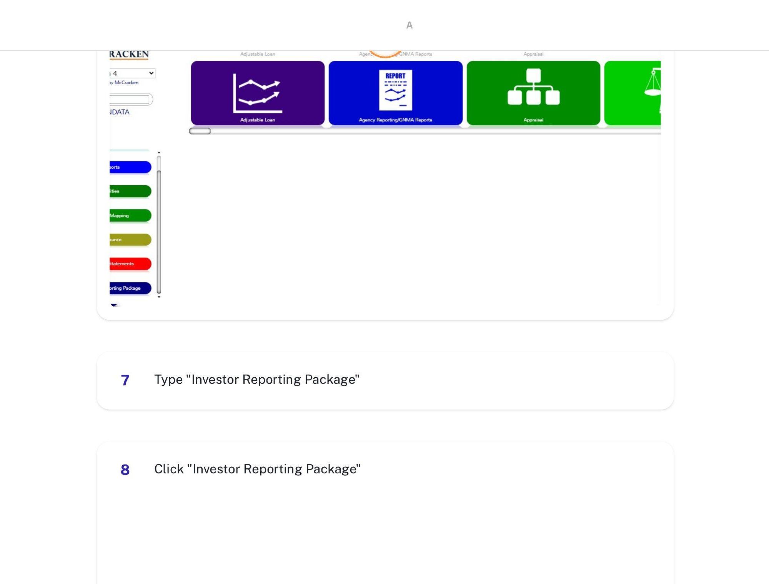
7. Select the widget
Click “Investor Reporting Package” in the results, then confirm to add it to your dashboard.
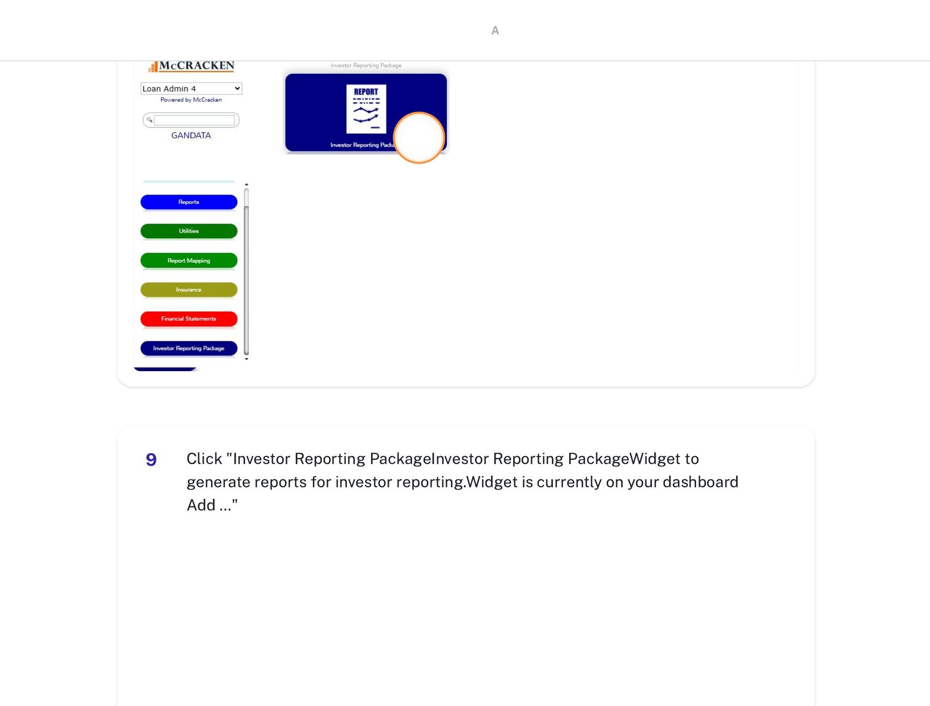
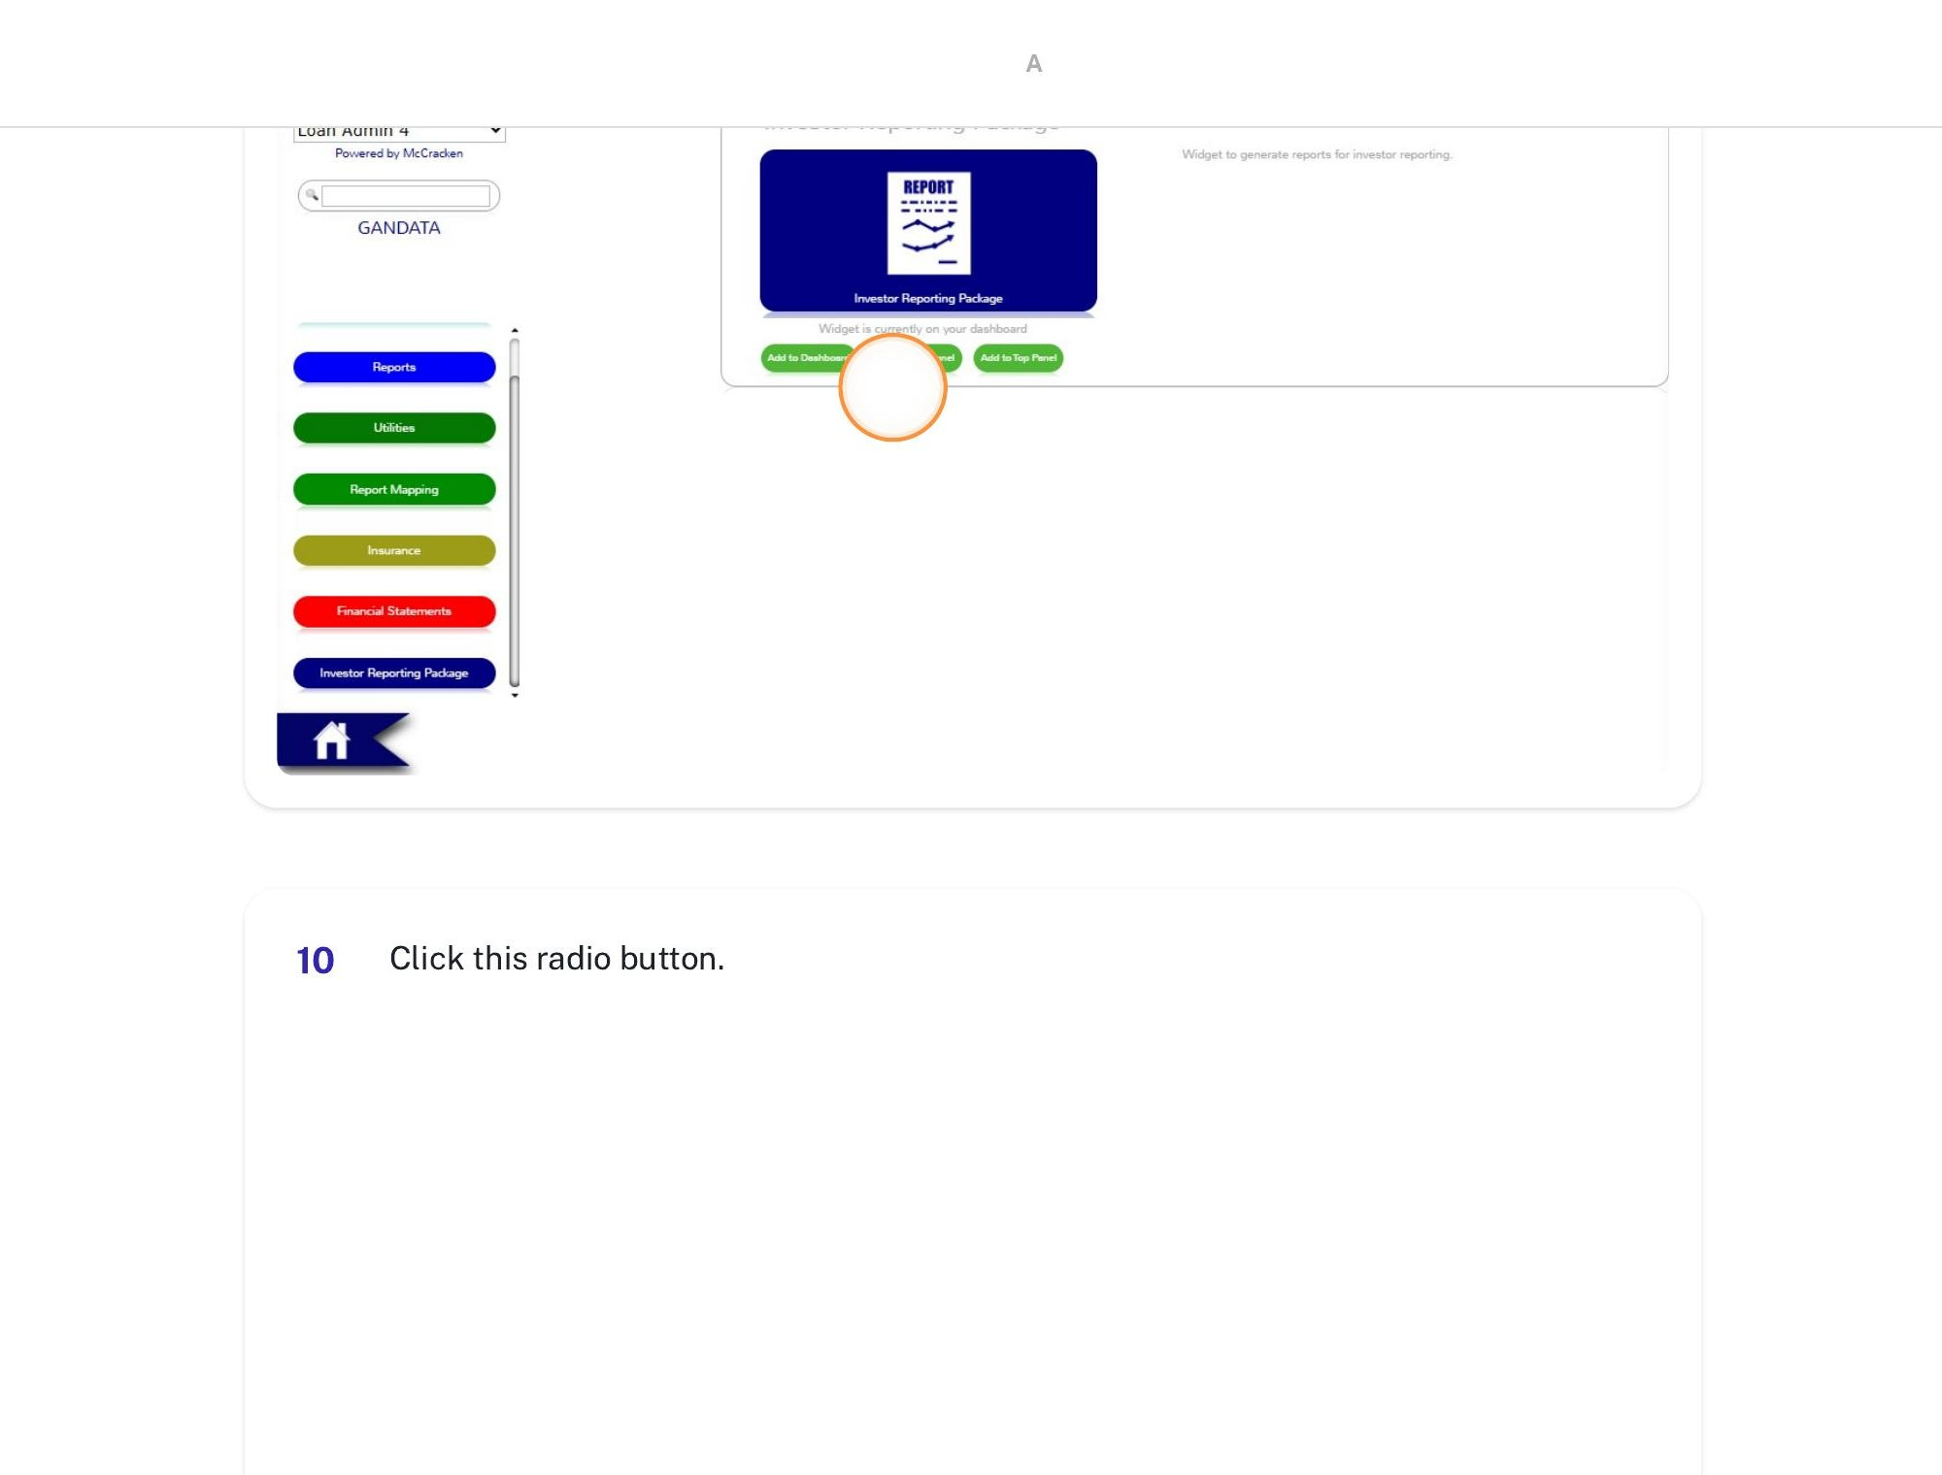

Configure Report Settings
8. Select “On-Demand”
In the Settings area at the top-right of the IRP panel, click the “On-Demand” radio button. This gives you the most current data rather than the prior day-end snapshot.
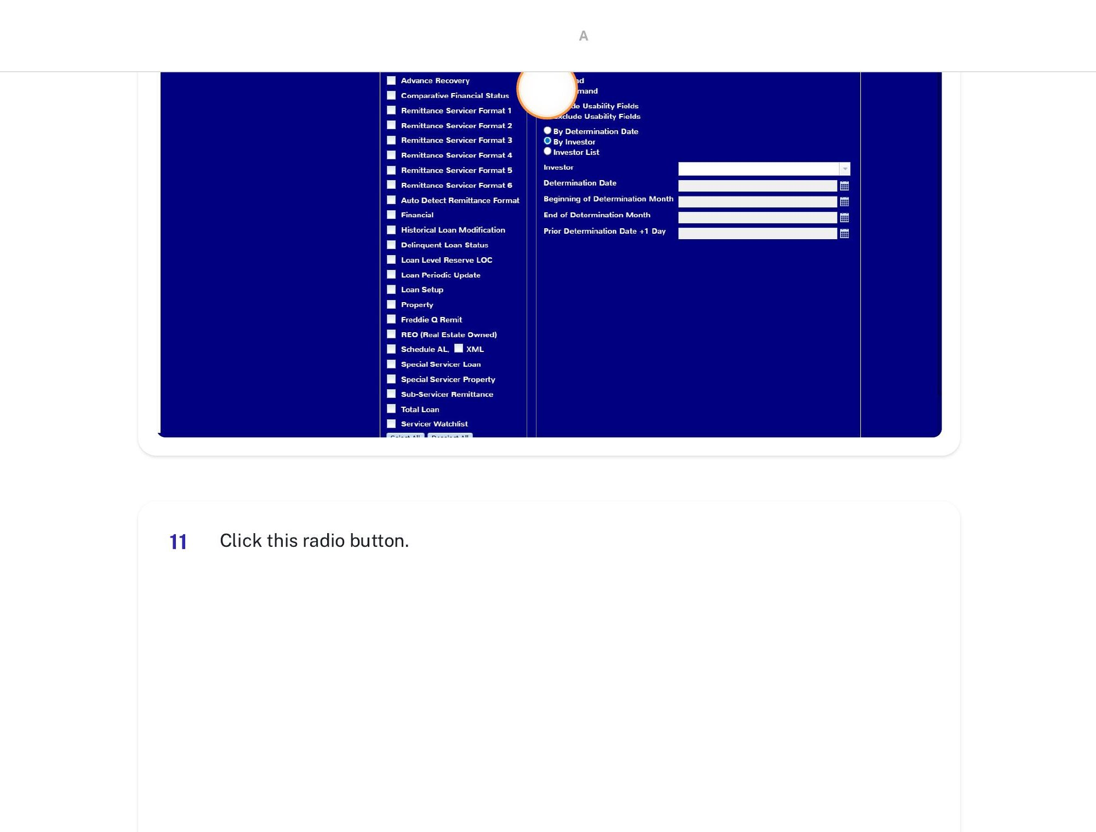
9. Select “By Determination Date”
Click the “By Determination Date” radio button. This groups all deals by their determination date, which is how the CREFC files are organized on the S: drive.
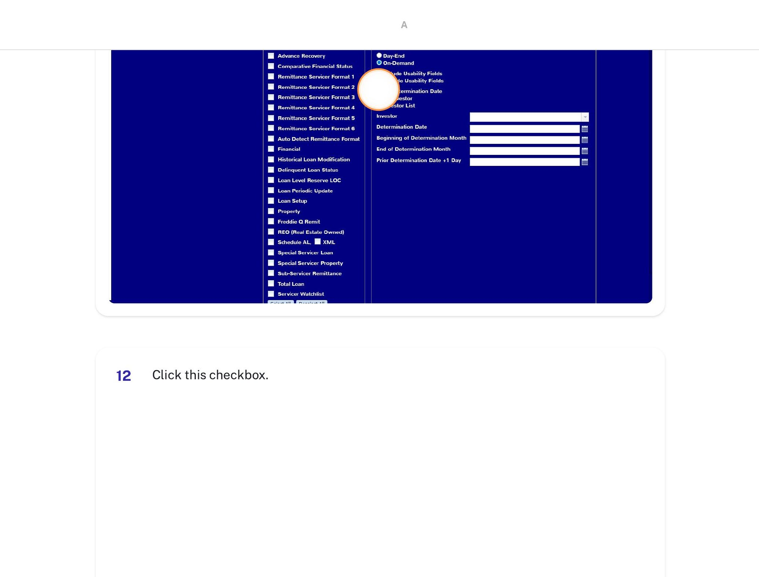

Select the Reports
10. Check “Loan Periodic Update”
In the Select Reports panel on the left, check the box next to “Loan Periodic Update.” This is the primary report that generates the PIRPXLPU (GANDATA) file the tool reads.
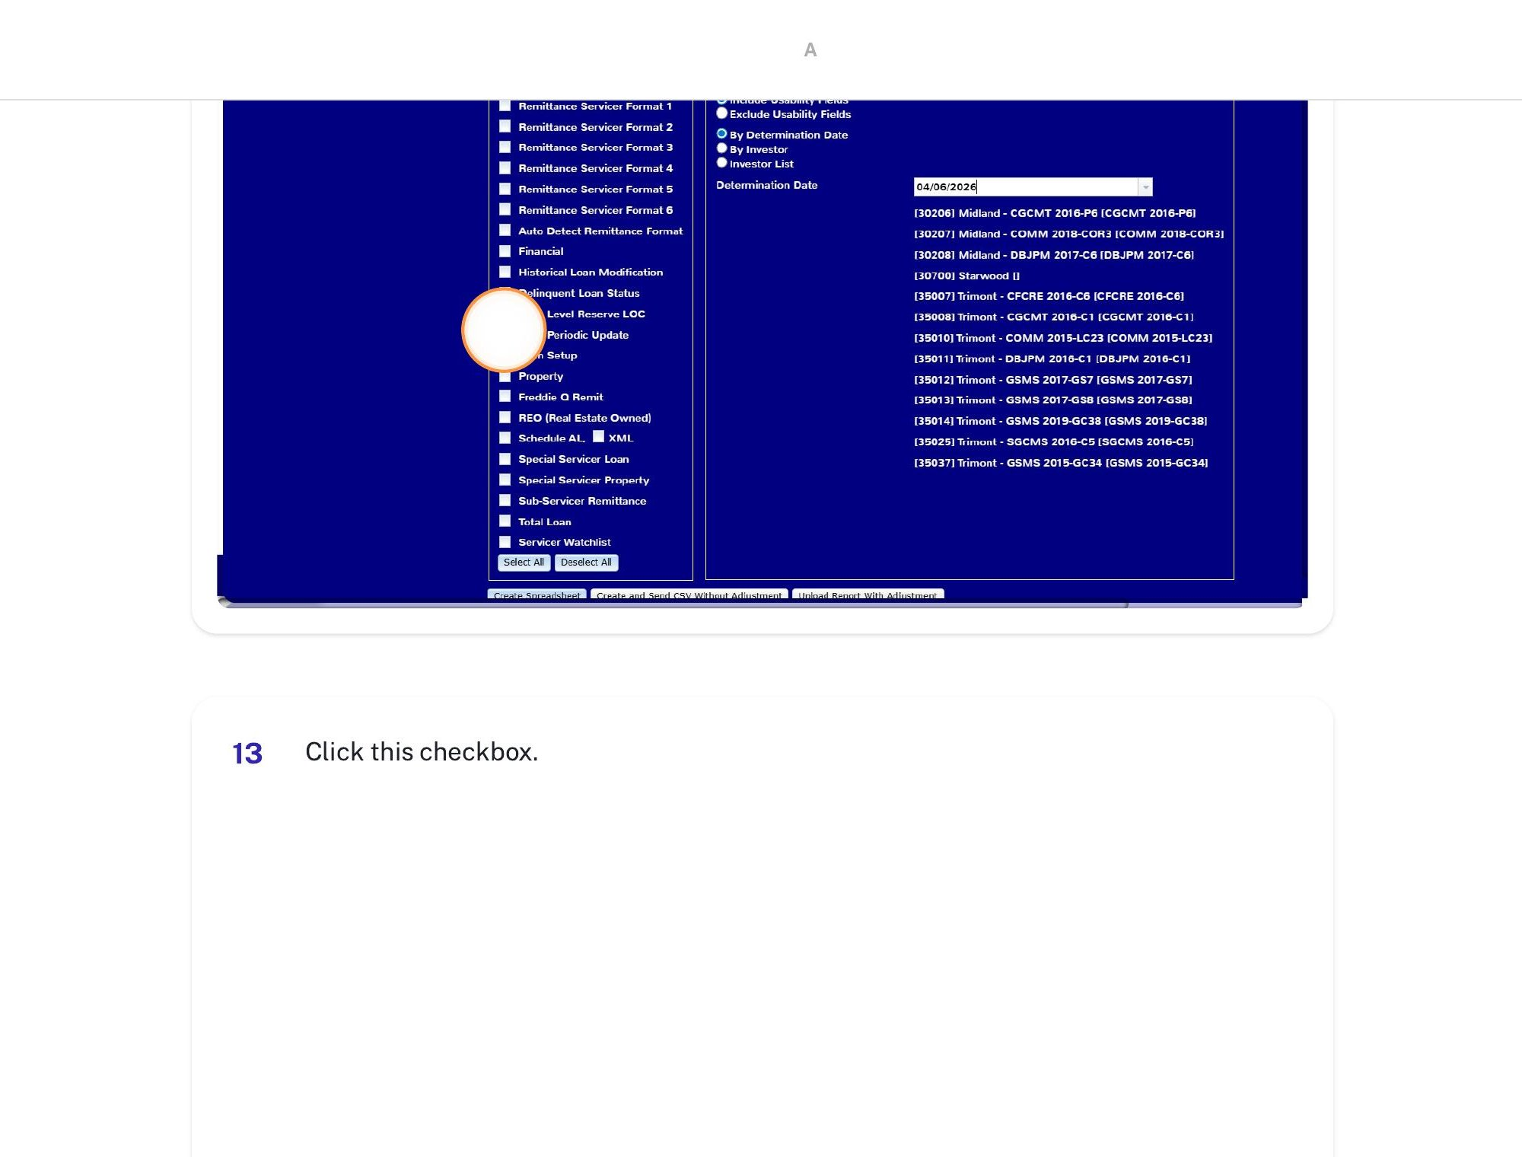
11. Check “Loan Level Reserve LOC”
Also check “Loan Level Reserve LOC” to include the PIRPXLLR file in the download.
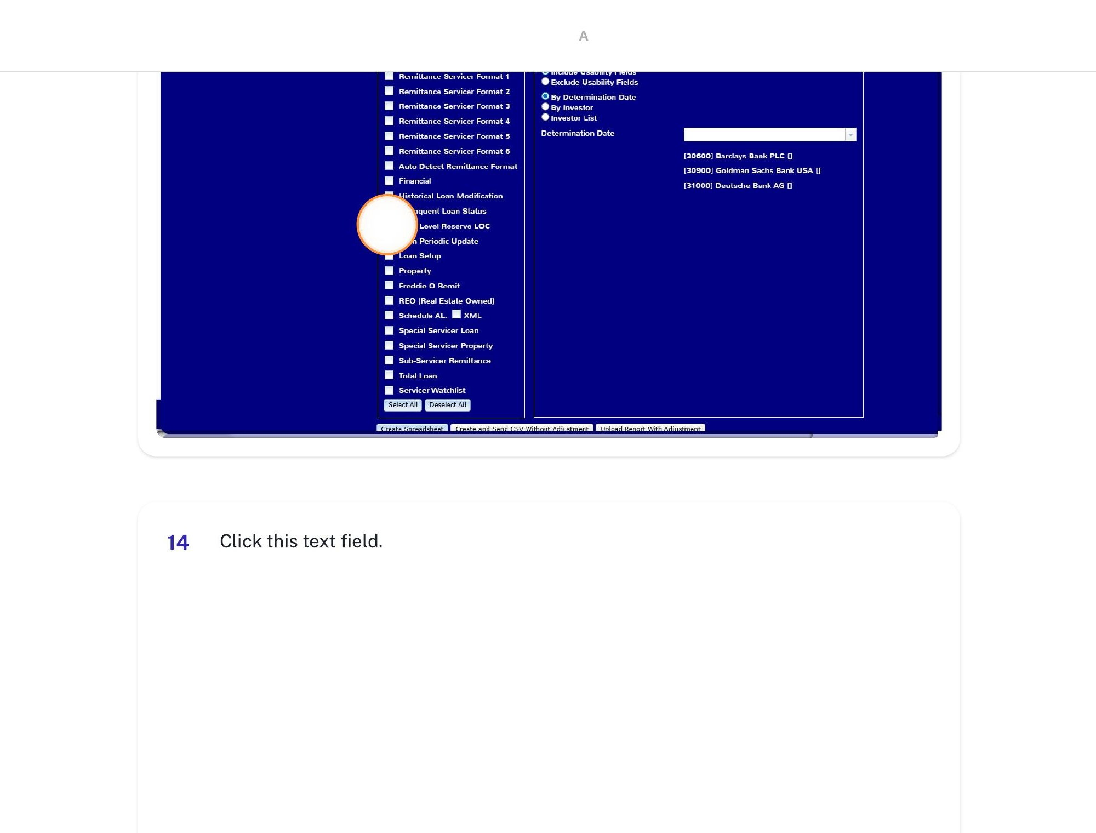

Choose the Date and Generate
12. Click the Determination Date dropdown
Click the Determination Date text field to open the date picker.
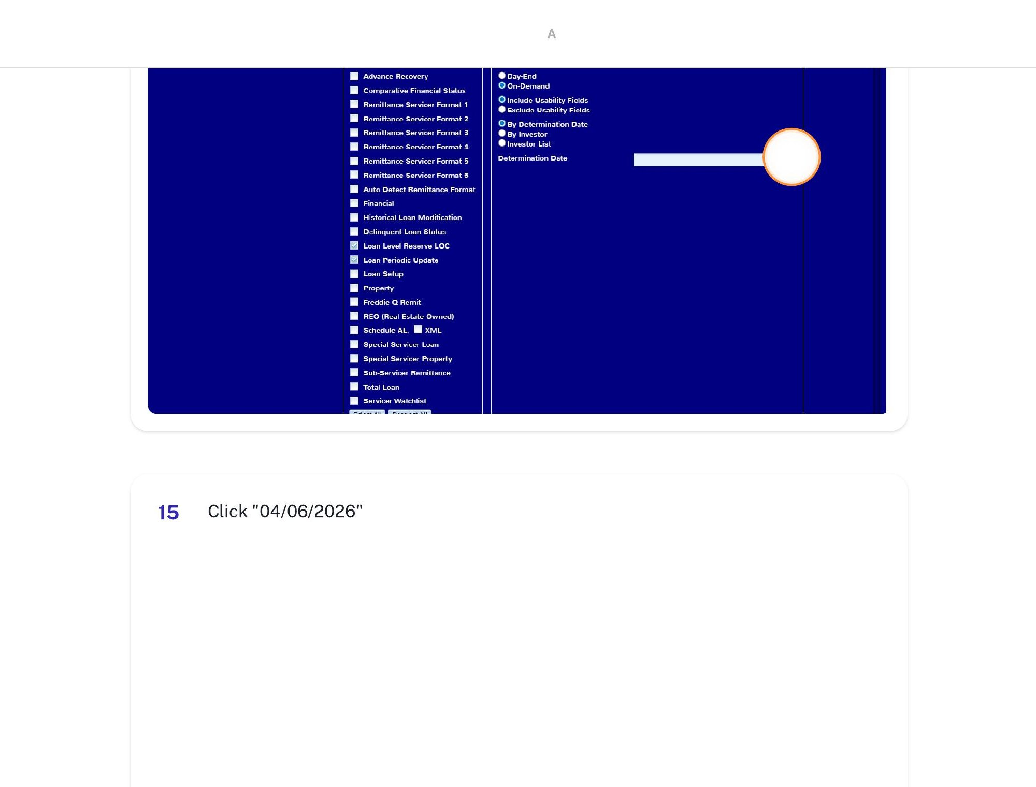
13. Select the determination date
Choose the current month’s determination date from the dropdown (e.g., 04/06/2026 for Batch 1). The deal list will populate based on your selection.
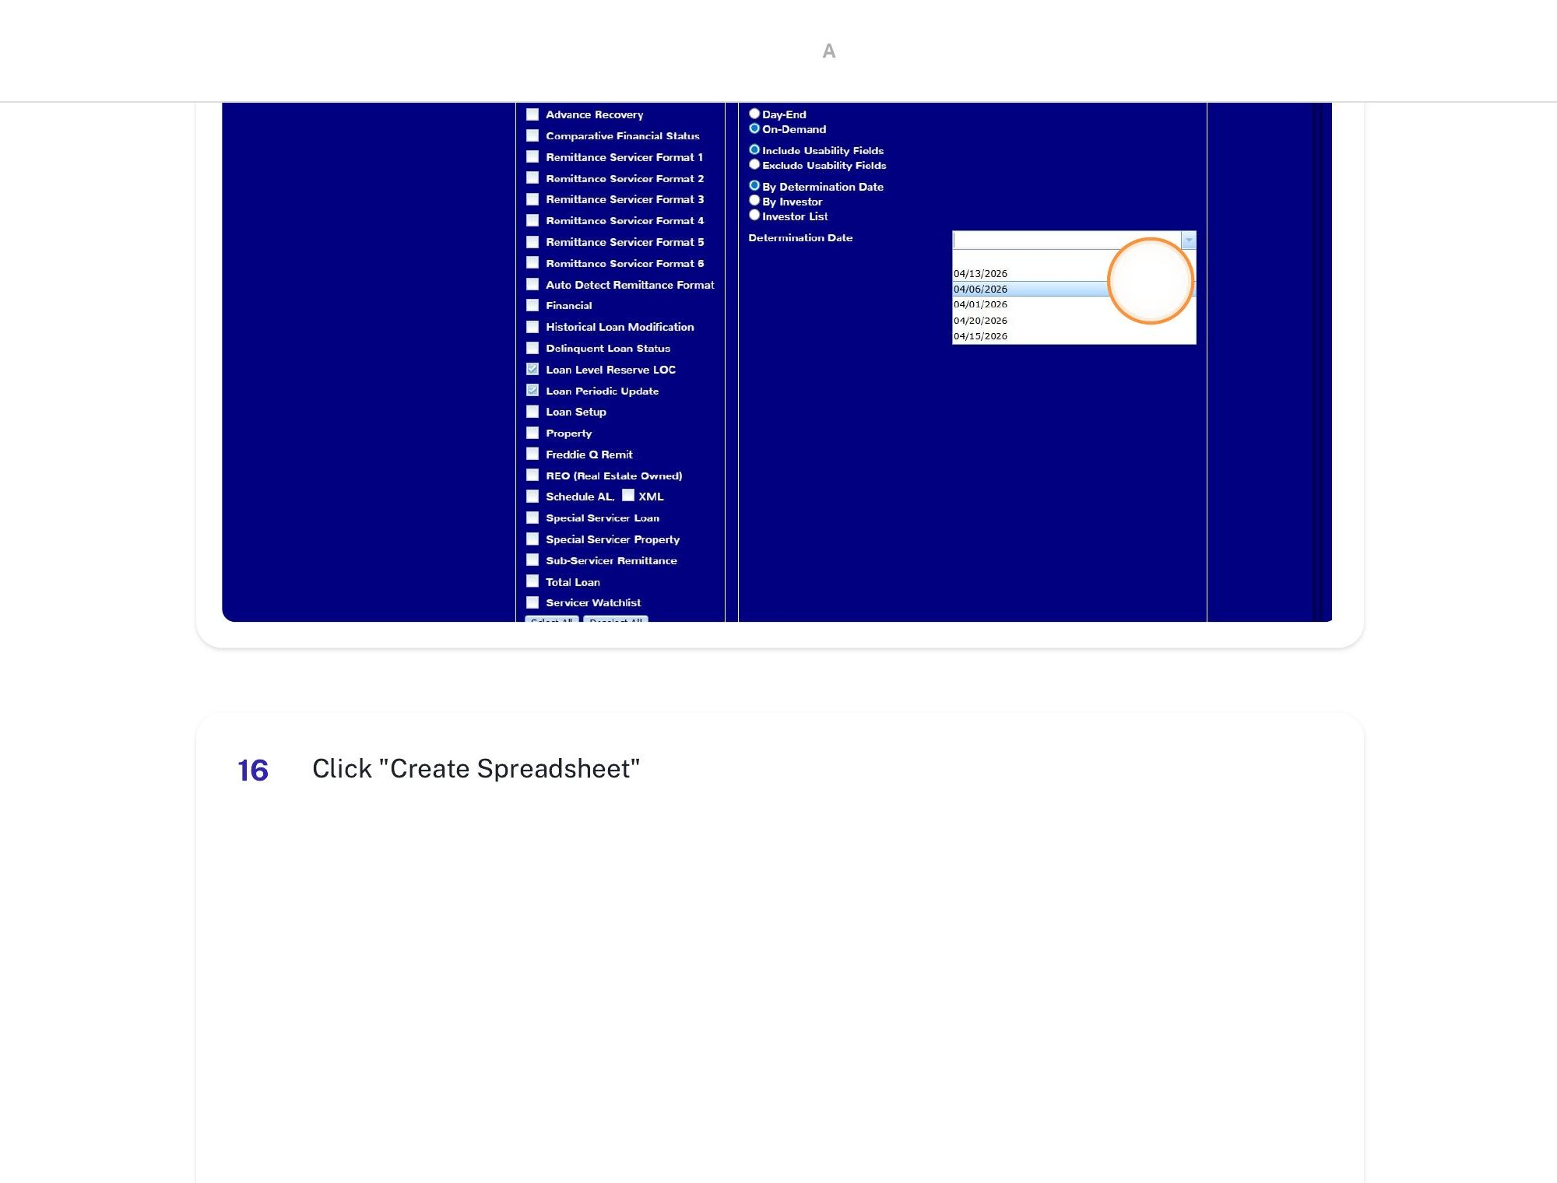
14. Click “Create Spreadsheet”
Click the “Create Spreadsheet” button at the bottom-left. The portal will generate and download an “Investor Reporting Package_MMDDYYYY” folder to your Downloads directory.
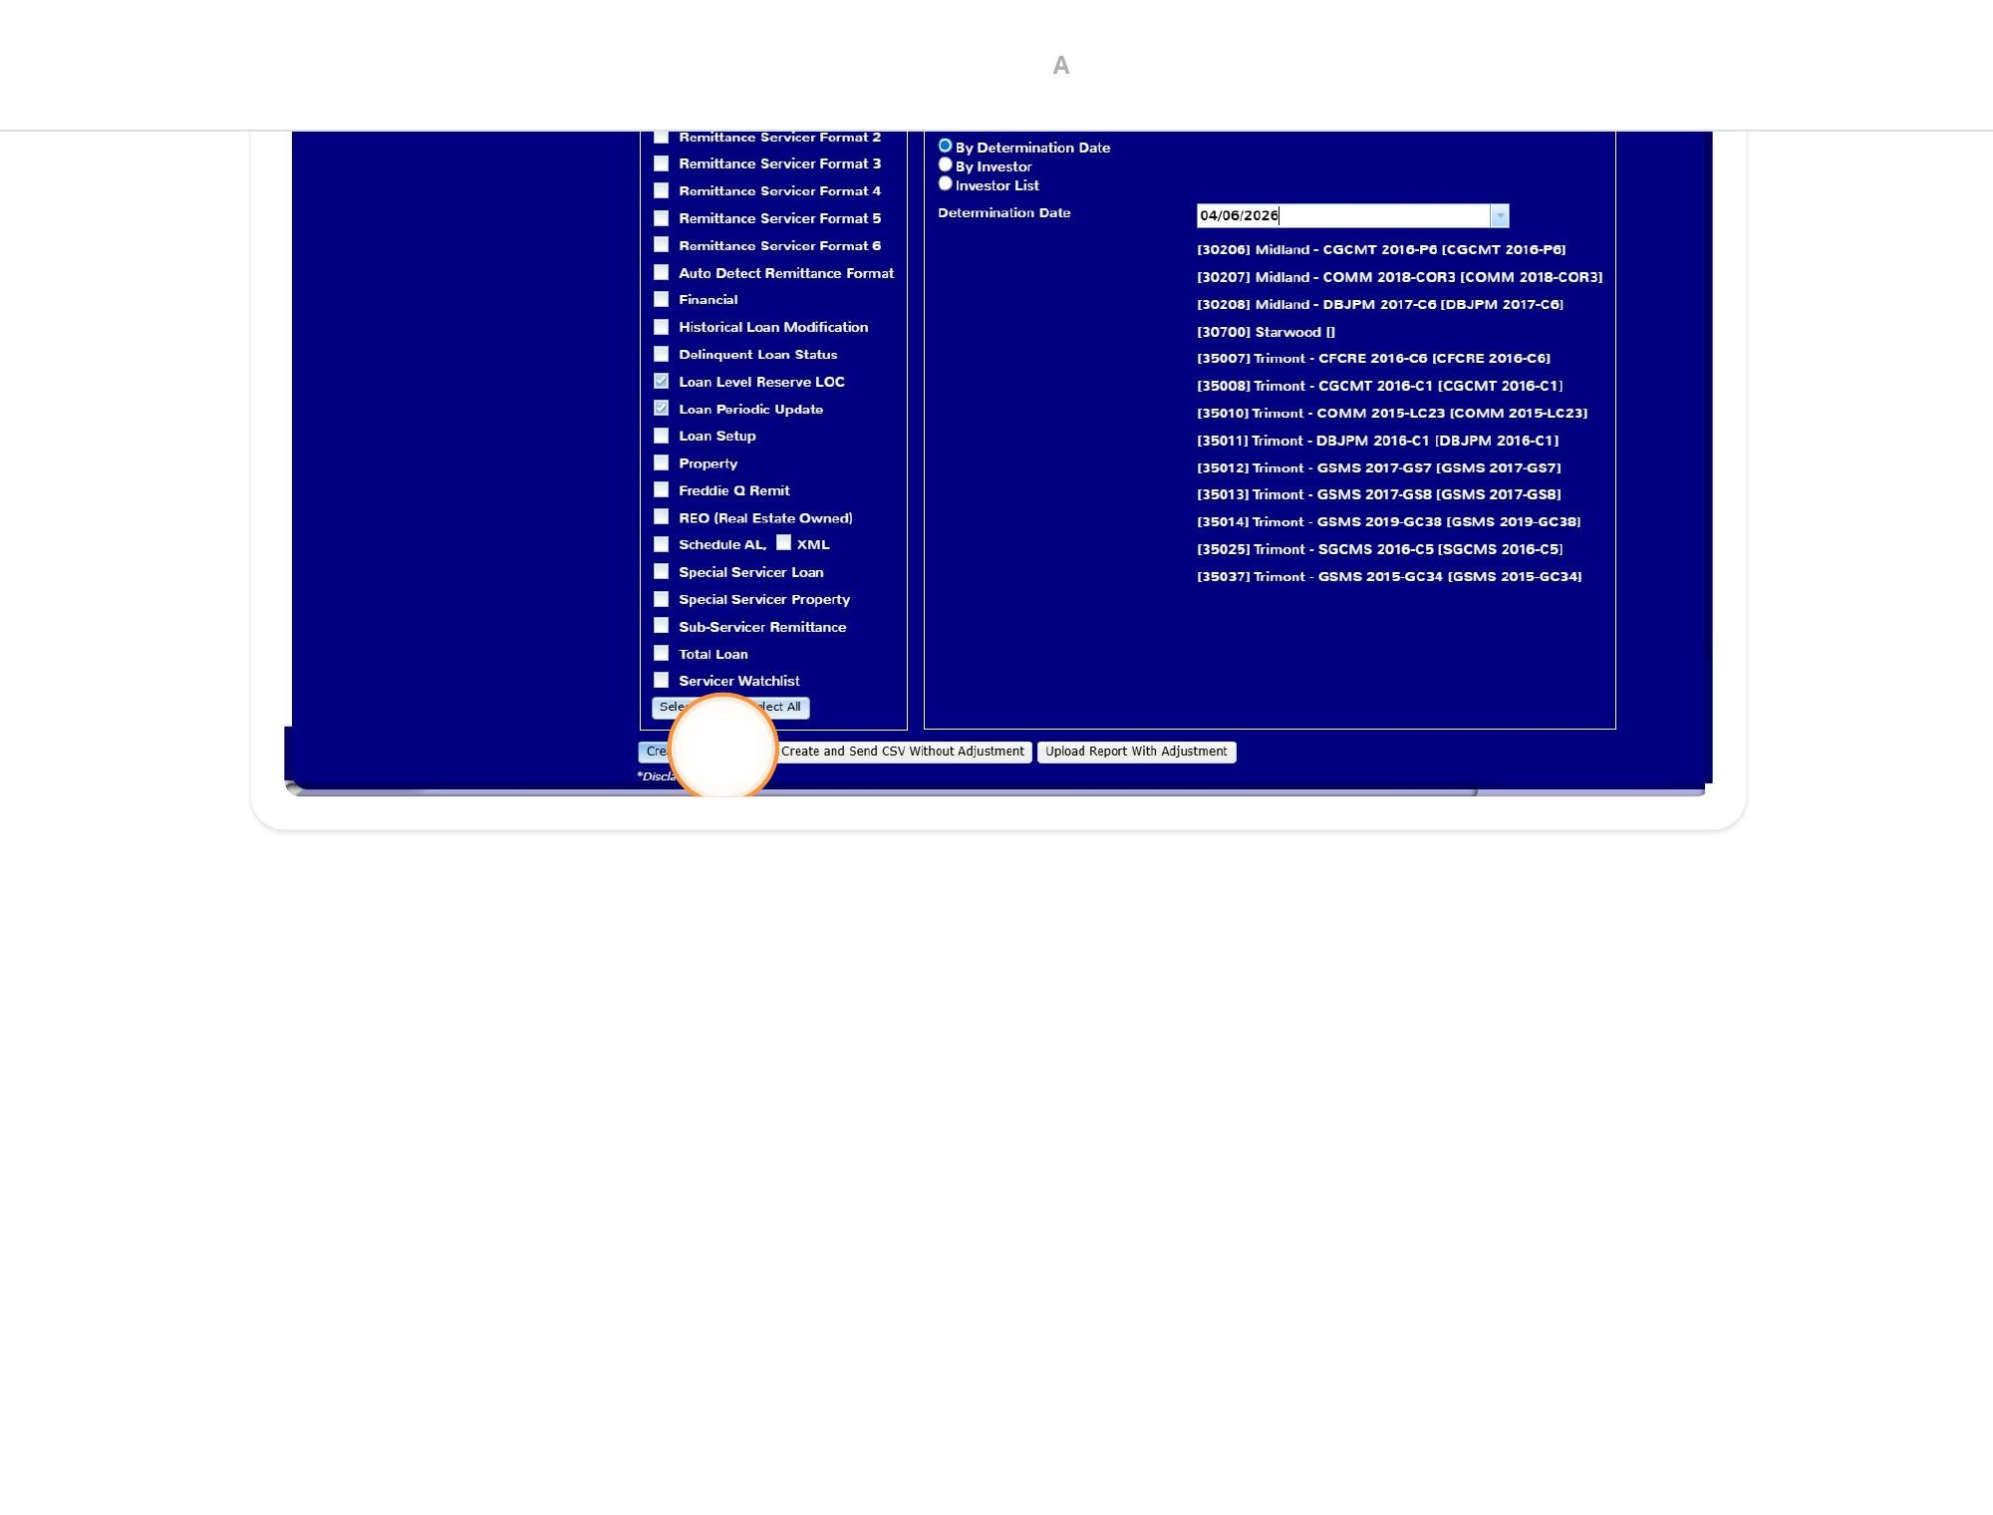
Tip: The Python tool auto-detects the most recent “Investor Reporting Package” folder in your Downloads directory.
Note: If a deal has multiple determination dates (e.g., the 6th and the 11th), you will need to run the download and tool separately for each determination date.

3. Step 2 — Run the Python Reporting Tool
The CMBS Reporting Tool is a Python automation script that reads the IRP source files and generates updated CREFC files for each active deal. The tool consists of three files:
S:\Lenders\Z. CMBS Test\6. CMBS Report - 10D Forms\Python\CMBS_Reporting_Tool.bat
S:\Lenders\Z. CMBS Test\6. CMBS Report - 10D Forms\Python\cmbs_report.py
S:\Lenders\Z. CMBS Test\6. CMBS Report - 10D Forms\Python\cmbs_config.py
CMBS_Reporting_Tool.bat is the launcher. cmbs_report.py is the main processing script. cmbs_config.py holds all configurable settings (paths, column mappings, deal overrides, servicer codes).
1. Double-Click CMBS_Reporting_Tool.bat
Navigate to the Python folder on the S: drive and double-click CMBS_Reporting_Tool.bat. It checks for Python and required packages (installs them on first run if missing), then launches cmbs_report.py.
2. Confirm or Override the IRP Folder
The tool scans your Downloads folder for the most recent “Investor Reporting Package” directory. It displays the detected folder name and asks you to confirm. Press Enter to accept, or paste a different path to override.
3. Review the Deal List
The tool reads the PIRPXLPU and PIRPXLLR files, identifies all active deals (filtering out paid-off loans with zero beginning balance), and displays a numbered list. Review the list to confirm the expected deals are present.
4. Press “Y” to Process All Deals
The tool asks “Process all N deals? (Y/n).” Press Y and Enter to begin processing. For each deal, the tool: (a) resolves the deal’s S: drive folder, (b) locates the prior-month CREFC files, (c) copies them into a new mm.yyyy subfolder, and (d) updates cells with IRP data.
5. Wait for Completion
Processing typically takes 1–3 minutes. A progress counter shows [1/N], [2/N], etc. When finished, the run log opens automatically in Excel.
First-time tip: For your first run, keep TEST_MODE = True and VALIDATION_MODE = True in cmbs_config.py. This writes output to the Z. CMBS Test folder and highlights all touched cells yellow.

4. Step 3 — Review the Run Log
The tool generates a 3-tab Excel log saved to S:\Lenders\Z. CMBS Test\Excel Log\. The log opens automatically after each run.
Tab | What to Look For
Deal Summary | Total deals, created count, skipped count, errors. Each deal row is color-coded: green = CREATED, red = ERROR.
File Detail | One row per file (Periodic, Property, Supplemental, Financial) per deal. Shows the full output path and any notes.
Run Log | Chronological log of every action. Filter by ERROR or WARN level to find issues.

Key Things to Verify
- All expected deals appear in the Deal Summary tab.
- No deals show ERROR status. If they do, check the Run Log tab for the specific error message.
- Files Created count is 4 for each deal (Periodic + Property + Supplemental + Financial).
- If any files show 0 loans matched, check the Run Log for WARN-level unmatched loan messages.

5. Step 4 — Spot-Check the CREFC Files
After reviewing the run log, open 2–3 deals in Excel and manually verify the updated values against the IRP source data.

Periodic File Checks
- Compare a few loan rows against the PIRPXLPU source. Verify Beginning Balance (col F), Paid Through Date (col H), and Scheduled Interest (col W) match.
- Confirm Reporting Period Begin Date (col EE) is one day before the IRP value.
- Check formula columns: G (=F–X), Y (=W+X), and AJ (=F–X) should contain formulas, not hardcoded values.
- If VALIDATION_MODE was True, script-touched cells will be highlighted yellow.

Property File Checks
- Verify that only the last block of rows was updated (rows sharing the most recent distribution date).
- Check that Distribution Date (col E) matches the IRP and Allocated Balance (col U) equals Ending Balance x Allocation Percentage (col T).

Supplemental File Checks
- Check A1 on each tab — the date should reflect the current determination date.
- Total Loan tab: verify Ending Balance (col I), Paid Through (col J), Total Scheduled P&I (col M).
- Res LOC Report tab: confirm the correct number of data rows and that TOTALS formulas reference the right range.

6. Step 5 — Upload CREFC Files to Servicer
Once the CREFC files have been verified, upload them to the master servicer through their designated submission channel.
- Navigate to the completed files at S:\Lenders\<Servicer>\Reporting\<Deal>\CREFC\mm.yyyy\.
- Upload via the servicer’s portal. Follow the servicer-specific upload process.
- Confirm receipt — verify that the servicer’s system acknowledges receipt of all files.
Best practice: Keep the run log Excel file for your records as an audit trail.

7. Step 6 — Prepare the 10-D Forms
The 10-D forms are a separate Excel template used only for Trimont deals. Each pool has its own tab with a pre-filled Form 10-D Information Report. You update the date fields each month, convert to PDF, and route for signature.

Open the 10-D Template
S:\Lenders\Z. CMBS Test\10-D Forms\Template and Instructions\10D Forms.xlsx

Update the Data Entry Tab
Open the “Data Entry” tab and update the following green-highlighted fields:
Field | Example Value | How to Determine
Reporting Date | 4/1/2026–4/30/2026 | Current calendar month range
Distribution Date (6th) | 4/12/2026 | Four business days after the 6th
Distribution Date (11th) | 4/17/2026 | Four business days after the 11th
Signature Date (6th) | 4/12/2026 | Matches the distribution date for the 6th
Signature Date (11th) | 4/17/2026 | Matches the distribution date for the 11th
Important: Only update the green-highlighted fields. The signer name (Michael Heagerty) and title (Principal) are pre-filled.

Verify Pool Tabs and Convert to PDF
Spot-check 2–3 individual pool tabs to confirm dates cascaded correctly, then print the entire workbook to PDF.
1. Print to PDF
Go to File → Print. Set the printer to “Microsoft Print to PDF.” Print all sheets to generate a single PDF.
2. Save the PDF
Save with the naming convention below.
S:\forms\10D Forms Signed\10D Forms_April 2026.pdf
Important: Save the signed PDF to S:\forms\10D Forms Signed\ — this is where the split script looks for the most recent signed PDF.

8. Step 7 — Email 10-D PDF to Michael for Signature
Michael Heagerty (Principal) signs the 10-D forms on behalf of NRC Group, Inc. Send him the PDF before the distribution date.

Compose the Email
- To: Michael Heagerty
- Subject: 10-D Forms for Signature — <Month Year>
- Attachment: The 10-D Forms PDF (e.g., 10D Forms_April 2026.pdf)
- Body: Brief message requesting his signature and noting the distribution date deadline.

Timing
Batch | Send to Michael By | Distribution Deadline
Batch 1 (6th) | 1–2 days before distribution | 4 business days after the 6th
Batch 2 (11th) | 1–2 days before distribution | 4 business days after the 11th

9. Step 8 — Process and Distribute Signed 10-Ds
Once Michael returns the signed PDF, use the automation scripts to split it into individual pool PDFs and email them to Trimont. All scripts are located here:
S:\Lenders\Z. CMBS Test\10-D Forms\Template and Instructions\Create & Email 10-D PDFs\

9a. Split the Signed PDF into Individual 10-Ds
The split script (split_email_10d_forms.py) automatically splits the signed multi-page PDF into one PDF per pool, using pool names from the 10D Forms.xlsx template. It reads the distribution date from each page and organizes the output into date-based subfolders.
S:\Lenders\Z. CMBS Test\10-D Forms\Template and Instructions\Create & Email 10-D PDFs\Step 2. Split 10 - D Script\split_email_10d_forms.py
1. Save the signed PDF
Save the signed PDF from Michael into S:\forms\10D Forms Signed\ (or the configured SOURCE_FOLDER in the script). The script automatically finds the most recently modified PDF in that folder.
2. Run the split script
Double-click split_email_10d_forms.py (or run it from command line). It reads the 10D Forms.xlsx template to get pool names, splits the signed PDF page by page, names each file after the pool (e.g., CGCMT 2016-C1-10D.pdf), and saves them into a month/date subfolder.
3. Verify the output
Check the output folder (S:\Forms\z.10-D Forms\<Month>\<M.D.YYYY>\) to confirm each pool has its own PDF and the naming is correct.

9b. Email Signed 10-Ds to Trimont
The email scripts automate creating and sending individual emails to Trimont with each pool’s signed 10-D attached. There are two options:
S:\Lenders\Z. CMBS Test\10-D Forms\Template and Instructions\Create & Email 10-D PDFs\Step 3. Send 10 - D Emails\Split_and_Email_10D.bat
S:\Lenders\Z. CMBS Test\10-D Forms\Template and Instructions\Create & Email 10-D PDFs\Step 3. Send 10 - D Emails\Create_10D_Emails.bat
S:\Lenders\Z. CMBS Test\10-D Forms\Template and Instructions\Create & Email 10-D PDFs\Step 3. Send 10 - D Emails\create_10d_emails.py
4. Run the email script
Double-click Split_and_Email_10D.bat (runs both the split and email steps together) or Create_10D_Emails.bat (runs only the email step if you’ve already split the PDF). The script creates emails to c3po@trimont.com with the individual signed 10-D PDFs attached.
- To: c3po@trimont.com
- CC: Chelsea, LeAnn
- Subject: Signed 10-D Forms — <Month Year>
- Attachments: Individual signed 10-D PDF for each pool
5. Review and send
The script stages the emails in Outlook. Review them before sending to confirm the correct attachments and recipients.
6. Send on the distribution date
Send the emails on or before the distribution date for that batch.

9c. Save Copies to Pool Folders
7. Archive to each pool’s CREFC folder
Copy each signed 10-D PDF into the corresponding pool’s CREFC folder for that month.
S:\Lenders\Trimont\Reporting\<Deal Folder>\CREFC\mm.yyyy\10-D <Pool Name>.pdf

9d. Set Calendar Reminder
After sending the second batch (11th-determination), set a calendar reminder for the day after the second distribution date to confirm everything was received.

10. Quick Reference

Key File Paths
Item | Path
CMBS Reporting Tool (.bat) | S:\Lenders\Z. CMBS Test\6. CMBS Report - 10D Forms\Python\CMBS_Reporting_Tool.bat
Main script | S:\Lenders\Z. CMBS Test\6. CMBS Report - 10D Forms\Python\cmbs_report.py
Config file | S:\Lenders\Z. CMBS Test\6. CMBS Report - 10D Forms\Python\cmbs_config.py
Run log output | S:\Lenders\Z. CMBS Test\Excel Log\
10-D template | S:\Lenders\Z. CMBS Test\10-D Forms\Template and Instructions\10D Forms.xlsx
Split 10-D script | S:\...\Create & Email 10-D PDFs\Step 2. Split 10 - D Script\split_email_10d_forms.py
Email 10-D script | S:\...\Create & Email 10-D PDFs\Step 3. Send 10 - D Emails\create_10d_emails.py
Split + Email launcher | S:\...\Create & Email 10-D PDFs\Step 3. Send 10 - D Emails\Split_and_Email_10D.bat
Email-only launcher | S:\...\Create & Email 10-D PDFs\Step 3. Send 10 - D Emails\Create_10D_Emails.bat
Signed 10-Ds archive | S:\Lenders\Trimont\Reporting\Z - 10-D Letters\Sent\
CREFC output (per deal) | S:\Lenders\<Servicer>\Reporting\<Deal>\CREFC\mm.yyyy\

Key Contacts
Person | Role | Contact
Michael Heagerty | 10-D signer (Principal) | Email for signature requests
Trimont | Master Servicer | c3po@trimont.com
Chelsea | CC on 10-D emails | Include on all 10-D distributions
LeAnn | CC on 10-D emails | Include on all 10-D distributions

Monthly Timeline
Day | Action | Notes
~5th | Download IRP for Batch 1 (6th det. date) | Run tool, review log, spot-check
6th | Prepare Batch 1 10-D forms, email to Michael | Update Data Entry tab, convert to PDF
~9th | Email signed Batch 1 10-Ds to Trimont | On or before distribution date
~10th | Download IRP for Batch 2 (11th det. date) | Run tool, review log, spot-check
11th | Prepare Batch 2 10-D forms, email to Michael | Update Data Entry tab, convert to PDF
~14th | Email signed Batch 2 10-Ds to Trimont | On or before distribution date
~15th | Confirm receipt, close out the month | Calendar reminder day after 2nd distribution

Servicer Code Mapping
IRP Code | S: Drive Folder | Servicer
K | KeyBank | KeyBank National Association
M | Midland | Midland Loan Services
TM | Trimont | Trimont Real Estate Advisors
WF | Trimont | Wells Fargo (serviced via Trimont)

